**Progress Report**

**- Increment 1 -**

**Group #5**

*Please use this template to describe your progress on the group project in the latest increment. Please do not change the font, font size, margins or line spacing. All the text in italic should be removed from your final submission.*

# Team Members

* *Jordan Bradley, jjb21g, JordanB2213.*
* *Jeongyeon Kim, jk22bl, okidoki4830*
* *Shashank Dontireddy, srd21b, ShashankDont*
* *Trevor Cooley, tdc22, trevordc1*
* *Bradley Lashley, bwl23*

1. **Project Title and Description**

*In our project we will be Creating a website that starts at a home page and has 2 options of games to choose from that will be accessible through links embed on the home page. By the end of the project, you should be able to navigate through the home page and access either game* *and return to the home page as well.*

1. **Accomplishments and overall project status during this increment**

*During this increment we created a website where we could switch between three tabs; the home page, Flappy Planes, Tic Tac Toe. We gave these tabs icons and also added functionality to the flappy planes game.*

1. **Challenges, changes in the plan and scope of the project and things that went wrong during this increment**

*Please describe here in detail:*

*Some challenges during this increment were learning how to code in HTML / CSS.*

*We were initially planning on coding our games in C++ or C#, however, most coding of games on webpages seems to be done in JavaScript.*

*We were not familiar with GitHub, so we had a hard time dealing with it.*

*- anything that was challenging during this increment and how you dealt with the challenges*

*- any changes that occurred in the initial plan you had for the project or its scope. Describe the reasons for the changes.*

*- anything that went wrong during this increment*

1. **Team Member Contribution for this increment**

*Please list each individual member and their contributions to* ***each of the deliverables in this increment*** *(be as detailed as possible). In other words, describe the contribution of each team member to:*

* 1. *the* ***progress report****, including the sections they wrote or contributed to*
  2. *the* ***requirements and design document****, including the sections they wrote or contributed to*
  3. *the* ***implementation and testing document****, including the sections they wrote or contributed to*
  4. *the* ***source code*** *(be detailed about* ***which*** *parts of the system each team member contributed to and* ***how****)*
  5. *the* ***video or presentation***
* ***Jordan Bradley – Helped Organize and create the documents, Progress report sections: 1, 2, 5, and 8. Requirements and Design Document sections:***  ***“Overview”, “Functional Requirements”, as well as Implementation and Testing parts 1, 2, 3, 4 edited them. I handled recording the video explaining our state in the project. I also set the bases for the tic tac toe game/code.***
* ***Trevor Cooley – Helped with building the homepage. Added icons to each of the navigational elements on the homepage where you can click the icon and navigate to the respective page/game. Added to sections 2 and 3 of Implementation and Testing Document as well as made section 5. Expanded on section 6 and 7 of Requirements and Design Document. Added to 1, 2 ,3, and 5 of progress report.***
* ***Shashank Dontireddy – Built the initial basic website and created the initial HTML files, also added navigation between the tabs of home page, Flappy Planes, and Tic Tac Toe. Organized the files into folders in GitHub. Helped with part 4 in Progress Report Document. Helped with part 1,2,3,4 of Implementation and Testing document. Requirements and Design Document I helped with Operating Environment, Use Case Diagram, and Sequential Diagram. Drafted the communication email with stakeholders.***
* ***Jeongyeon Kim – Helped build home page. Helped with part 4,6 in Progress Report Document. Helped with part 2 in Software Requirements and Design Document. I wrote the codes for flappy_planes.html, game.js, and flappy_styles.css files.***
* ***Bradley Lashley Started Requirements and Design document # 7.***

1. **Plans for the next increment**

*We will complete flappy planes. We are going to make it playable in two ways: mouse click and keyboard. We will add the ability to record scores based on the time you survived.*

1. **Stakeholder Communication**

Dear Stakeholders,

I'd like to take this opportunity to update you on the status of 5 Guy Games. We have made significant strides over the past few weeks; I would like to share some of the key developments we have made during this period of time.

Project Summary:

The purpose of this project is to make a website that allows you to play two games Flappy Planes and Tic Tac Toe, while being able to navigate between the games and the home page.

Project Progress:

During these past few weeks, we have built a website that allows smooth navigation between the games and the home page. And a basic implementation of flappy planes as well as started on building Tic Tac Toe.

Setbacks:

The team is overall not familiar with HTML/CSS and JavaScript, so it has taken some time to learn the languages, therefore the project is slower than expected.

Conclusion:

During the past few weeks, we have built a website that allows navigation between the games and the home page. We have also started working on the games and have flappy planes ready and are working on Tic Tac Toe. We have also run into some issues due to the coding languages, but we have made significant progress on the project. If you have any questions or requests for additional information, please contact us back at fiveguygames@gmail.com.

*Best Regards,*

*FiveGuyGames*

1. **Link to video**

<https://youtu.be/f3FhtHldKok>

[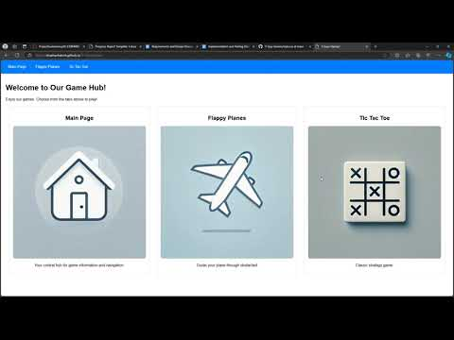](https://youtu.be/f3FhtHldKok)